**Program to swap two 8-bit data using 8085 processor**.

**Program :**

LDA 2500

MOV B,A

LDA 2501

STA 2500

MOV A,B

STA 2501

HLT

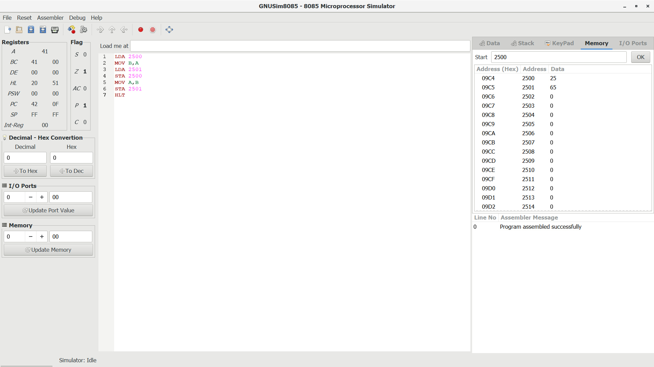**Output :**